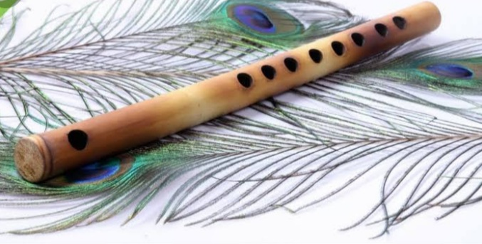

**Flute :**

The flute is a family of musical instruments in the woodwind group. Unlike woodwind instruments with reeds, a flute is an aerophone or reedless wind instrument that **produces its sound from the flow of air across an opening**. ... In China, a playable bone flute was discovered, dated approximately 9000 years old.

**Link:** [**https://www.britannica.com/art/flute-musical-instrument**](https://www.britannica.com/art/flute-musical-instrument)

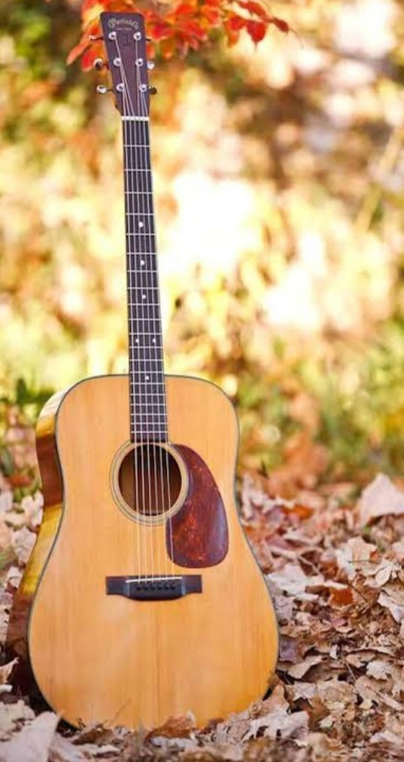

**Guitar :**

The guitar is a fretted musical instrument that typically has **six strings**. It is held flat against the player's body and played by strumming or plucking the strings with the dominant hand, while simultaneously pressing selected strings against frets with the fingers of the opposite hand.

**Link:** [**https://www.britannica.com/art/guitar**](https://www.britannica.com/art/guitar)

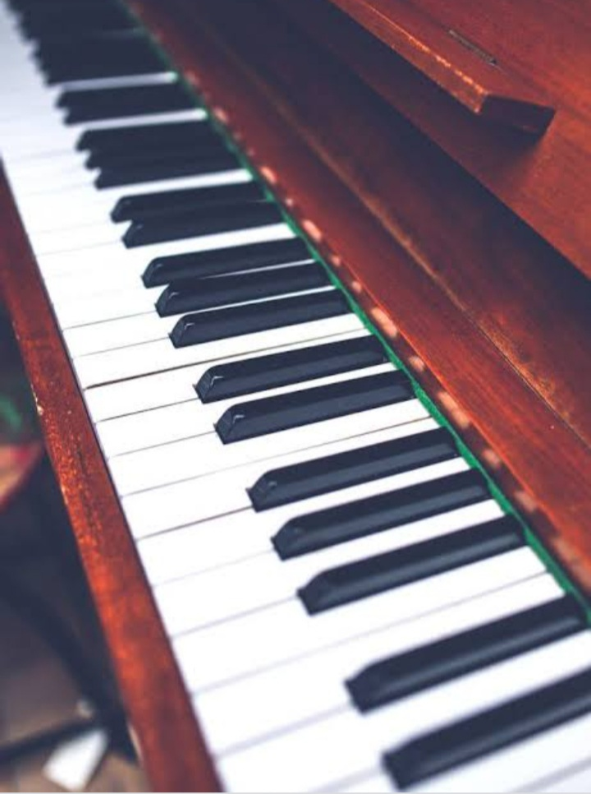

**Piano :**

* A piano is a keyboard musical instrument that has wire strings that sound when struck by felt-covered hammers operated from a keyboard.
* The standard modern piano has 88 keys and has a compass of seven full octaves plus a few keys. ...
* There have been many great pianists over time with a variety of styles

**Link :** **->** [**https://www.britannica.com/art/piano**](https://www.britannica.com/art/piano)

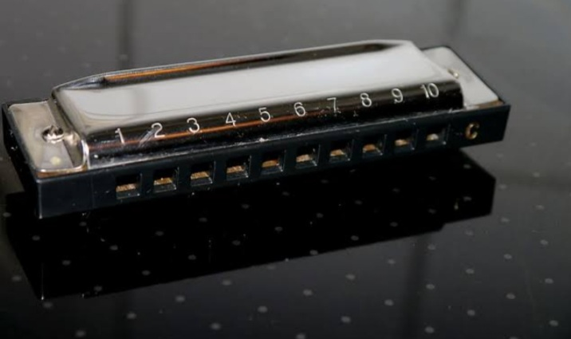

**Harmonica :**

The harmonica, also known as a French harp or mouth organ, is a **free reed wind instrument** used worldwide in many musical genres, notably in blues, American folk music, classical music, jazz, country, and rock. The many types of harmonica include diatonic, chromatic, tremolo, octave, orchestral, and bass versions.

**Link :** [**https://www.britannica.com/art/harmonica**](https://www.britannica.com/art/harmonica)

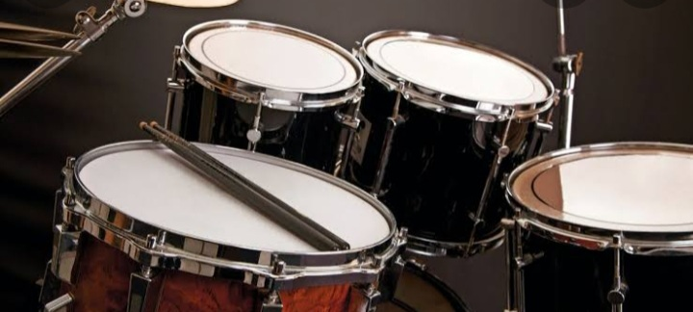

**Drum :**

The drum is a **member of the percussion group of musical instruments**. ... Drums consist of at least one membrane, called a drumhead or drum skin, that is stretched over a shell and struck, either directly with the player's hands, or with a percussion mallet, to produce sound.

**Link :**  [**https://www.britannica.com/art/drum-musical-instrument**](https://www.britannica.com/art/drum-musical-instrument)